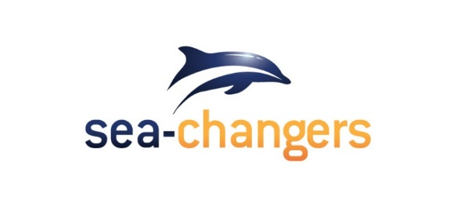
The Sea-Changers Coastal Fountain Fund
Supported by Bunzl plc

Who and what will we fund?
The Sea-Changers Coastal Fountain Fund is available for applicants from UK based community organisations. We welcome applications from a wide variety of groups and entities. We expect to be providing partial funding for fountain installation projects where other funds are also being sought or are already in place.
ELIGIBILITY CRITERIA

What is this fund for?
Bids must be for funding of water fountains/bottle filling stations at or near UK beaches/marinas/seaside locations.

- We expect bidders to make use of Refill’s existing good practice guidance in developing their plans. https://refill.org.uk/drinking-water-fountains/ This covers all practical aspects of getting a fountain installed.
- Installed fountains must be mapped on the Refill app.
- In line with advice from Refill, we expect the fountain provider to be MIW as they offer a range of fountains that can best withstand outdoor coastal locations.
How will applications be evaluated?
Eligible applications will be evaluated against the following criteria:

EVALUATION CRITERIA

- Need and impact - There must be a clear need (and impact). You need to show the proposed fountain will be placed in an area with significant public use / lots of littering. We will also need applications to have a built-in means to evaluate impact in terms of measuring the amount of water drawn (via a water meter) and thereby the potential number of plastic bottles saved.

- Viability to be operational within 2020 – We wish to see applications that can be implemented and put in place within 2020 and preferably before the 2020 Summer season. Applications should show a clear plan and end date for the fountain(s) to be operational.

- Sustainability – Applicants must show that they have in place the means and funding (beyond the funds applied for) to ensure the fountain will be properly maintained for at least the following 2 years. You will also need to show you know who to involve and have plans in place to involve all necessary stakeholders and obtain the appropriate permissions to implement the installation (e.g. landowners, water companies, local community) and to maintain the fountain in the longer term.

- Value for money - The maximum amount available is £2,000 per fountain. We want to maximise the number of fountains funded, so where applications request less than that amount per fountain, they will be more likely to be successful. We recognise that this amount cannot fully fund each fountain’s purchase, installation and ongoing maintenance, so applicants will therefore need to have other funds identified and available. You need to be able to demonstrate you can fully fund your fountain(s) for at least 2 years (see also Sustainability).

How will we allocate funding?
Funding decisions will be made by a small Grants Panel which will comprise Sea-Changers’ Trustees and/or volunteers with input from our sponsor Bunzl. The panel will have unfettered discretion over how the funds are allocated. They will ensure that the purpose and practice of any receiving organisation can be demonstrated to conform to Sea-Changers’ funding criteria and will meet our charitable aims.
The process we will follow is shown in the diagram below:

Timings for the process will be confirmed to applicants following receipt of their application. We are sorry that we cannot guarantee to give individual feedback to unsuccessful applicants.
It is likely that we will ask for MIW or other contractors (if applicable) to invoice us directly for the funds allocated; rather than passing the funds into the applying organisation’s bank account.
Measuring the success of funding
Sea-Changers will require all successful applicants to The Sea-Changers Coastal Fountain Fund to provide evaluation data. This will entail providing regular feedback on the amount of water drawn (every six months after installation).

